**Maximum Path Sum**

By starting at the top of the triangle below and moving to adjacent numbers on the row below, the maximum total from top to bottom is 23.

**3**  
**7** 4  
2 **4** 6  
8 5 **9** 3

That is, 3 + 7 + 4 + 9 = 23.

Find the maximum total from top to bottom in **"triangle.txt"**, a 15K text file containing a triangle with one-hundred rows.

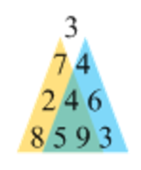*Algorithm help:*

Standing at the top of the triangle we must choose between going left and right. To make the optimal choice (which maximizes the sum), we would have to know how large a sum we can get if we go either way. To answer the question, we would basically have to solve the two smaller problems which are marked with blue and orange in the figure to the right.

olving a sub-problem

We can break each of the sub-problems down in a similar way, and we can continue to do so until we reach a sub-problem at the bottom line, consisting of only one number. At this point, the question becomes trivial to answer, since the answer is the number itself. Once that question is answered we can move up one line, and answer the questions posed there